Andre Hardy – Project 7-1

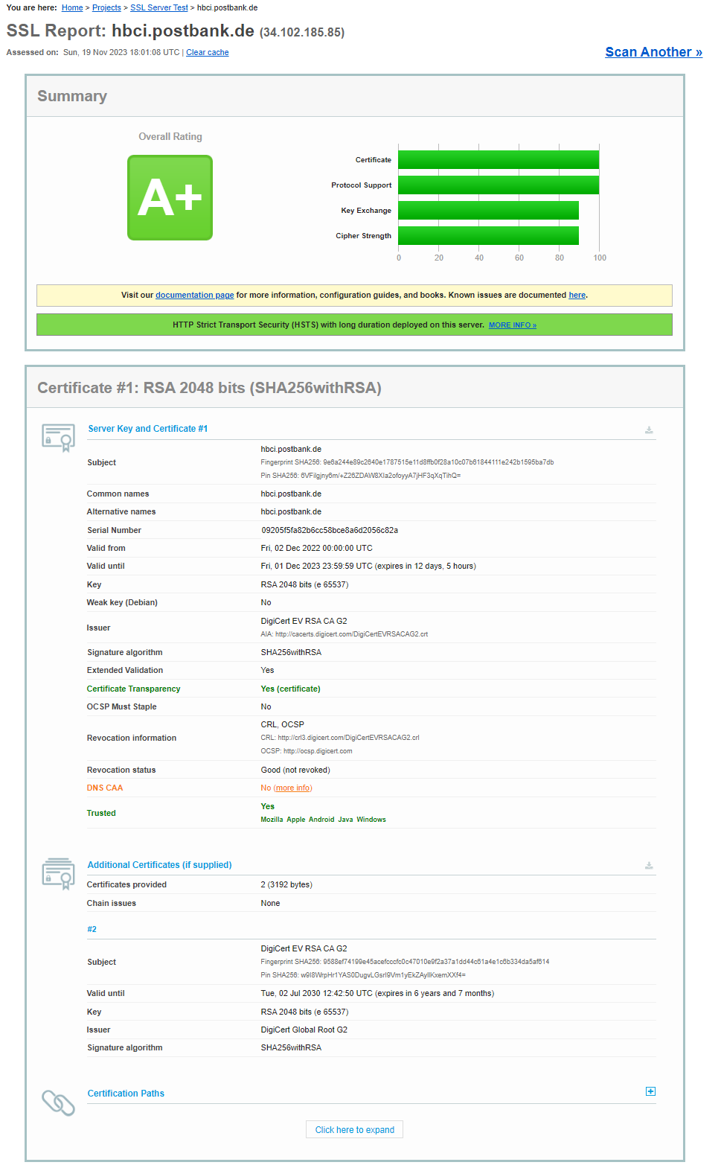
13. Enter the name of your school or work URL and generate a report. What score did it receive?
A: YTI portal received a score of A
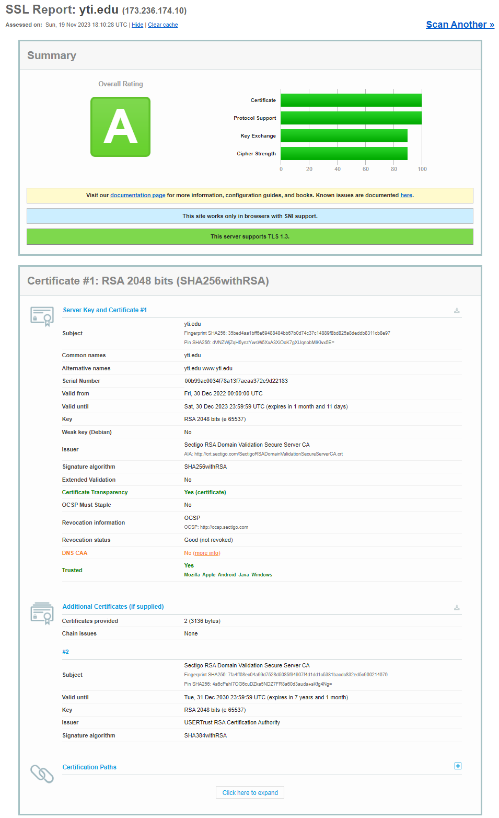

14. Review the Summary, Authentication, Configuration, Cipher Suites, and handshake simulation. Would you agree with this site’s score?
A: I believe this score was correct and fair.

